Kaizen Suggest for Electricity
30 กรกฎาคม 2564
วันที่เสนอแนะ ..............................................
- วัตถุประสงค์
ลดต้นทุน/ประหยัด
นวัตกรรมใหม่
ความปลอดภัย
ลดระยะเวลา
ด้านสิ่งแวดล้อม


ด้านคุณภาพ
- นางจุริน สุกระ
จัดทำที่โกยขยะจากแกลนน้ำยาหรือปิ๊บ
- ข้อมูลผู้เสนอ ........................................................................... 3) เรื่องที่เสนอ .........................................................................................................
- นางพรทิพย์ พูนสวัสดิ์

.................................................................................................. ..........................................................................................................
- นางสาวทิพวัลย์ พรมญาณ
.................................................................................................. ..........................................................................................................
.................................................................................................. ..........................................................................................................
- ปัญหาที่พบ/สภาพปัจจุบัน 5) รายละเอียดการปรับปรุง/พัฒนา

เปลี่ยนการสั่งซื้อที่โกยขยะ เป็นการจัดทำที่โกยขยะจากแกลนน้ำยาแทน เพื่อประหยัดงบประมาณ

เนื่องจากปัจจุบันมีการสั่งซื้อวัสดุที่โกยขยะแบบพลาสติก ทำให้ชำรุดง่าย ต้องทำการสั่งซื้อใหม่บ่อยครั้ง

.................................................................................................. ..........................................................................................................
.................................................................................................. ..........................................................................................................
.................................................................................................. ..........................................................................................................
.................................................................................................. ..........................................................................................................
.................................................................................................. ..........................................................................................................
- รูปภาพก่อนปรับปรุง 7) รูปภาพหลังปรับปรุง
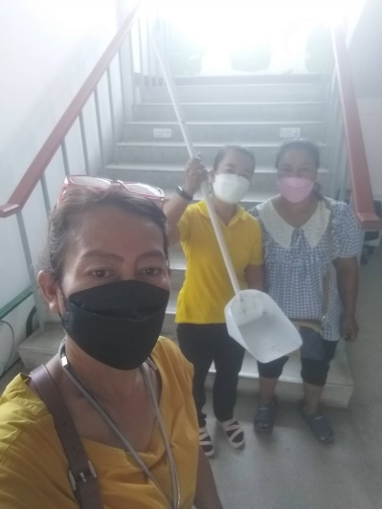
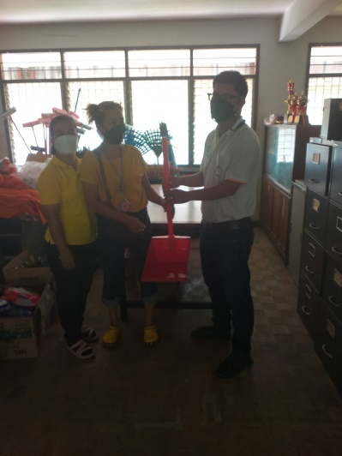

- ประโยชน์ที่คาดว่าจะได้รับ 9) ความเห็นหัวหน้างาน

ลดต้นทุน/ค่าใช้จ่าย/เพิ่มรายได้ (แสดงวิธีการคำนวณ)
ปรับปรุง
ไม่ผ่าน
ผ่าน
.................................................................................................................................

ลดเวลาทำงาน/เร็วขึ้น
.................................................................................................................................

ด้านความปลอดภัย
.................................................................................................................................
ลดต้นทุนในการสั่งซื้ออุปกรณ์ที่โกยขยะ

........................................................................................................................... 10) ความเห็นคณะกรรมการ
ผ่าน
ปรับปรุง
ไม่ผ่าน
........................................................................................................................... ...........................................................................................................................
........................................................................................................................... ...........................................................................................................................

