Kaizen Suggest for Electricity
30 กรกฎาคม 2564
วันที่เสนอแนะ ..............................................
- วัตถุประสงค์
นวัตกรรมใหม่
ความปลอดภัย
ลดระยะเวลา
ด้านสิ่งแวดล้อม
ลดต้นทุน/ประหยัด


ด้านคุณภาพ
ใช้อุปกรณ์เช็ดกระจกแม่เหล็ก แทนการปืนหน้าต่าง ออกไปเช็ด
- นายศรีศักดิ์ ขุนทรัพย์
- ข้อมูลผู้เสนอ ........................................................................... 3) เรื่องที่เสนอ .........................................................................................................
กระจกด้านนอกอาคารสูง เพื่อลดความเสี่ยง เพิ่มความปลอดภัย
- นางดนิดา ผลผลา
.................................................................................................. ..........................................................................................................
- นางสมใจ ศรีม่วง
.................................................................................................. ..........................................................................................................
.................................................................................................. ..........................................................................................................
- ปัญหาที่พบ/สภาพปัจจุบัน 5) รายละเอียดการปรับปรุง/พัฒนา
เปลี่ยนมาใช้อุปกรณ์ที่ทำจากแม่เหล็กมาเช็ดกระจกแทนเพื่อผู้ปฏิบัติงานไม่ต้องปีนออกไปเช็ดนอกตัวอาคาร

เนื่องจากปัจจุบันการทำความสะอาดกระจกอาคารสูง ยังปฏิบัติงานแบบเดิมคือการปีนออกไปเช็ด ทำให้เสี่ยงแก่ผู้ปฏิบัติงาน

.................................................................................................. ..........................................................................................................
.................................................................................................. ..........................................................................................................
.................................................................................................. ..........................................................................................................
.................................................................................................. ..........................................................................................................
.................................................................................................. ..........................................................................................................
- รูปภาพก่อนปรับปรุง 7) รูปภาพหลังปรับปรุง
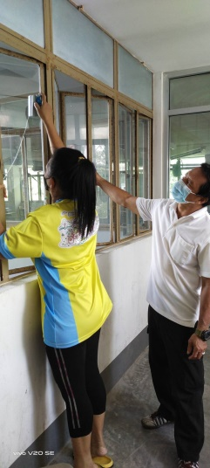
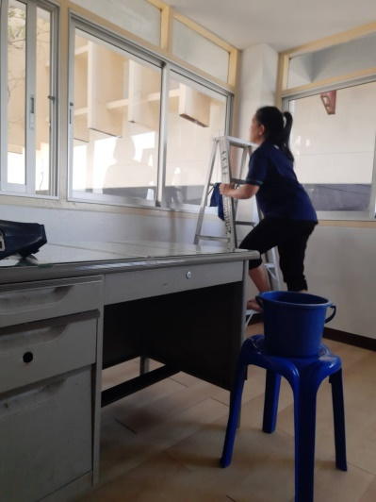

- ประโยชน์ที่คาดว่าจะได้รับ 9) ความเห็นหัวหน้างาน
ลดต้นทุน/ค่าใช้จ่าย/เพิ่มรายได้ (แสดงวิธีการคำนวณ)
ปรับปรุง
ไม่ผ่าน
ผ่าน
.................................................................................................................................

ลดเวลาทำงาน/เร็วขึ้น
.................................................................................................................................

ด้านความปลอดภัย
.................................................................................................................................
ลดเวลาทำงาน เมื่อต้องทำการเช็ดกระจก และทำให้ผู้ปฏิบัติงานปลอดภัยไม่ต้องปีนออกไปเช็ดกระจก
........................................................................................................................... 10) ความเห็นคณะกรรมการ
ผ่าน
ปรับปรุง
ไม่ผ่าน
........................................................................................................................... ...........................................................................................................................
........................................................................................................................... ...........................................................................................................................

