Kaizen Suggest for Electricity
30 กรกฎาคม 2564
วันที่เสนอแนะ ..............................................
- วัตถุประสงค์
นวัตกรรมใหม่
ความปลอดภัย
ลดระยะเวลา
ด้านสิ่งแวดล้อม
ลดต้นทุน/ประหยัด


ด้านคุณภาพ
ใช้เครื่องสแกนอุณหภูมิพร้อมเจลอัตโนมัติ แทนเครื่องสแกนอุณหภูมิหน้าผาก และกระปุกกดเจลแอลกอฮอล์เพิ่มความปลอดภัย
- นางวาสนา สุวรรณสงเคราะห์
- ข้อมูลผู้เสนอ ........................................................................... 3) เรื่องที่เสนอ .........................................................................................................
- นางศิรินทิพย์ พรหมคีรี
.................................................................................................. ..........................................................................................................
เพื่อลดระยะเวลาและเพื่อความปลอดภัยของผู้ปฏิบัติงาน
- นางสาวกัญต์ชญานี วารุณี
.................................................................................................. ..........................................................................................................
.................................................................................................. ..........................................................................................................
- ปัญหาที่พบ/สภาพปัจจุบัน 5) รายละเอียดการปรับปรุง/พัฒนา
เปลี่ยนเครื่องมือในการปฏิบัติงาน โดยใช้เครื่องเครื่องสแกนอัตโนมัติพร้อมเจล ที่สามารถลดการสัมผัสบุคคลที่เข้ามาติดต่อ ณ
อาคาร 20 และลดการเสี่ยงการติดเชื้อไวรัสของบุคลากรที่ได้รับ
มอบหมายให้ปฏิบัติหน้าที่ และลดจำนวนผู้ปฏิบัติงานลงจากเดิม 2
คน เหลือเพียง 1 คน
เนื่องจากปัจจุบันมาตรการป้องกันการแพร่ระบาดของไวรัสโควิด-19 ยังใช้เครื่องสแกนหน้าผาก และการกดเจลจากกระปุก ซึ่งทำให้
บุคลากรงานอาคารสัมผัสกับบุคคลที่มาติดต่องาน ณ อาคาร 20
จึงทำให้มีความเสี่ยง และต้องใช้บุคลากร จำนวนครั้งละ 2 คน
ผลัดเปลี่ยนหมุนเวียนกันไป
.................................................................................................. ..........................................................................................................
.................................................................................................. ..........................................................................................................
.................................................................................................. ..........................................................................................................
.................................................................................................. ..........................................................................................................
.................................................................................................. ..........................................................................................................
- รูปภาพก่อนปรับปรุง 7) รูปภาพหลังปรับปรุง
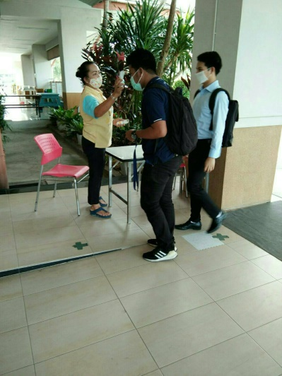

- ประโยชน์ที่คาดว่าจะได้รับ 9) ความเห็นหัวหน้างาน
ลดต้นทุน/ค่าใช้จ่าย/เพิ่มรายได้ (แสดงวิธีการคำนวณ)
ปรับปรุง
ไม่ผ่าน
ผ่าน
.................................................................................................................................

ลดเวลาทำงาน/เร็วขึ้น
.................................................................................................................................

ด้านความปลอดภัย
.................................................................................................................................
ลดเวลาทำงาน และเกิดความปลอดภัยกับผู้ปฏิบัติงานในการสัมผัสผู้ติดเชื้อไวรัสโควิด-19
........................................................................................................................... 10) ความเห็นคณะกรรมการ
ผ่าน
ปรับปรุง
ไม่ผ่าน
........................................................................................................................... ...........................................................................................................................
........................................................................................................................... ...........................................................................................................................

