Kaizen Suggest for Electricity
7 กรกฎาคม 2564
วันที่เสนอแนะ ..............................................
- วัตถุประสงค์
นวัตกรรมใหม่
ความปลอดภัย
ลดระยะเวลา
ด้านสิ่งแวดล้อม
ลดต้นทุน/ประหยัด


ด้านคุณภาพ
ปรับเปลี่ยนการใช้ผ้าเย็บสำเร็จแทนการผูกม้วนยาว
- นางวีลัด ศรีเอียด
- ข้อมูลผู้เสนอ ........................................................................... 3) เรื่องที่เสนอ .........................................................................................................
เพื่อลดระยะเวลาในการจับจีบผ้า
- นางโสพิศ ยศศิริ
.................................................................................................. ..........................................................................................................
- นางสุมณฑา รัตนอุดม
.................................................................................................. ..........................................................................................................
- นางสุวรรณา นุ้ยสุภาพ
........................... .......................................................................
- ปัญหาที่พบ/สภาพปัจจุบัน 5) รายละเอียดการปรับปรุง/พัฒนา
เปลี่ยนใช้ผ้าเย็บสำเร็จแทนการผูกผ้าม้วนยาว ทำให้ประหยัดเวลาและกำลังคน

เนื่องจากปัจจุบันแม่บ้านยังคงใช้วิธีจับจีบผ้าแบบเดิม ซึ่งใช้เวลาค่อยข้างใช้เวลา และใช้กำลังคน

.................................................................................................. ..........................................................................................................
.................................................................................................. ..........................................................................................................
.................................................................................................. ..........................................................................................................
.................................................................................................. ..........................................................................................................
.................................................................................................. ..........................................................................................................
- รูปภาพก่อนปรับปรุง 7) รูปภาพหลังปรับปรุง
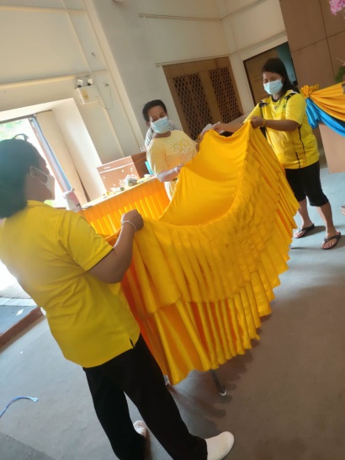
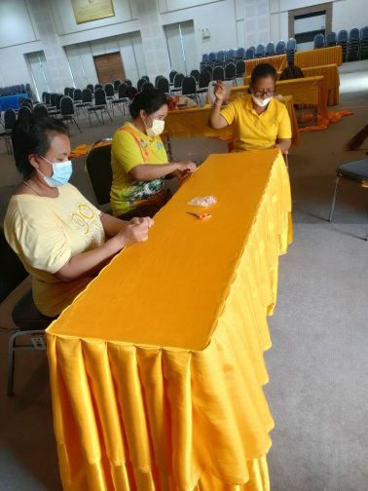

- ประโยชน์ที่คาดว่าจะได้รับ 9) ความเห็นหัวหน้างาน
ลดต้นทุน/ค่าใช้จ่าย/เพิ่มรายได้ (แสดงวิธีการคำนวณ)
ปรับปรุง
ไม่ผ่าน
ผ่าน
.................................................................................................................................

ลดเวลาทำงาน/เร็วขึ้น
.................................................................................................................................

ด้านความปลอดภัย
.................................................................................................................................
ลดเวลาทำงาน ลดกำลังคน เมื่อต้องจัดสถานที่ดำเนินกิจกรรม
........................................................................................................................... 10) ความเห็นคณะกรรมการ
ผ่าน
ปรับปรุง
ไม่ผ่าน
........................................................................................................................... ...........................................................................................................................
........................................................................................................................... ...........................................................................................................................

